**Near Real-Time Stream Processing Pipeline with AWS**

* **Bhushan Sagar**

**………………………………………………………………………………………………………………………**

**Business Overview:**

In today's data-driven world, businesses rely on real-time insights to make timely decisions and gain a competitive edge. Implementing a near real-time data processing pipeline can significantly enhance operational efficiency, customer experience, and decision-making processes. This project focuses on building such a pipeline using AWS services, catering to businesses aiming to harness the power of their streaming data.

**Data Pipeline:**

The data pipeline is designed to handle streaming data efficiently, from ingestion to analysis. It begins with data ingestion through Kinesis Data Streams, providing scalable and durable log storage. DynamoDB acts as a real-time data store, ensuring seamless integration with DynamoDB Streams enabling capturing changes in real-time. Event Bridge orchestrates event-driven architecture, connecting various AWS services for smooth data flow. Kinesis Firehose transforms and delivers data to S3 for further analysis using tools like Athena.

**Dataset Description:**

The dataset comprises order data generated by a mock data generator script utilizing Python's random module. The data follows a NoSQL structure, consisting of key-value pairs. Each entry in the dataset represents an order and includes various attributes related to the order transaction. These attributes typically include details such as order ID, product name, quantity, price, and other relevant information. The dataset is structured to facilitate efficient processing and analysis within a NoSQL database environment, enabling seamless integration into the data processing pipeline.

Top of Form

➔ Languages- ● Python3

➔ Services - ● AWS S3, DynamoDB, Kinesis Data Streams, Event Bridge, Kinesis Firehose, Aws Lambda, CloudWatch, Athena

➔ Tools - ● AWS CLI for deployment and configuration.

**Learning:**

Through this project, team members gain hands-on experience with:

- Configuring and utilizing various AWS services for real-time data processing.

- Implementing event-driven architecture for seamless integration and scalability.

- Writing Lambda functions for data transformation and processing.

**Optimization:**

Continuous optimization is crucial for enhancing the pipeline's efficiency and reducing costs. Some optimization strategies include:

- Fine-tuning Kinesis Data Streams to match throughput requirements.

- Implementing data compression techniques to reduce storage and transfer costs.

- Utilizing auto-scaling features to adapt to varying workload demands.

**Questions That Arise: Exploring Alternatives:**

1. **Why not leverage Apache Kafka for addressing this problem statement?**

Utilizing Apache Kafka for the described problem statement could be a viable alternative depending on specific requirements and preferences. Apache Kafka is a distributed streaming platform known for its scalability, fault-tolerance, and real-time data processing capabilities.

However, while Apache Kafka offers numerous advantages, it also introduces additional complexity and overhead compared to managed services like AWS Kinesis. Setting up and managing a Kafka cluster requires careful configuration, monitoring, and maintenance efforts. Additionally, Kafka may entail higher operational costs, especially when considering infrastructure provisioning and ongoing management tasks.

Ultimately, the decision to use Apache Kafka or AWS Kinesis depends on factors such as the specific use case, existing infrastructure, technical expertise, scalability requirements, and cost considerations. Both solutions offer robust capabilities for building real-time data processing pipelines, and the choice should align with the organization's goals and priorities.

(

Note: I opted for Kinesis due to my preference for establishing an end-to-end AWS-native data pipeline.

)

1. **Why did I choose to incorporate Kinesis Firehose into the pipeline?**

I chose to incorporate Kinesis Firehose into the pipeline primarily to optimize performance and streamline data delivery. Directly writing stream data to S3 could lead to multiple write requests and potentially impact performance. By leveraging Kinesis Firehose as an intermediary, I can efficiently batch and buffer the data before it's written to S3. This approach helps ensure smoother data delivery while benefiting from the real-time capabilities of Kinesis Data Streams.

1. **Why did I choose to use Lambda functions for data transformation instead of relying on the transformation capabilities provided by Event Bridge?**

Lambda functions offer greater flexibility and customization for data transformation tasks compared to the basic transformation capabilities provided by Event Bridge. They allow for complex transformations and integration with external systems, making them more suitable for handling diverse transformation requirements within the pipeline.

**Architecture:**

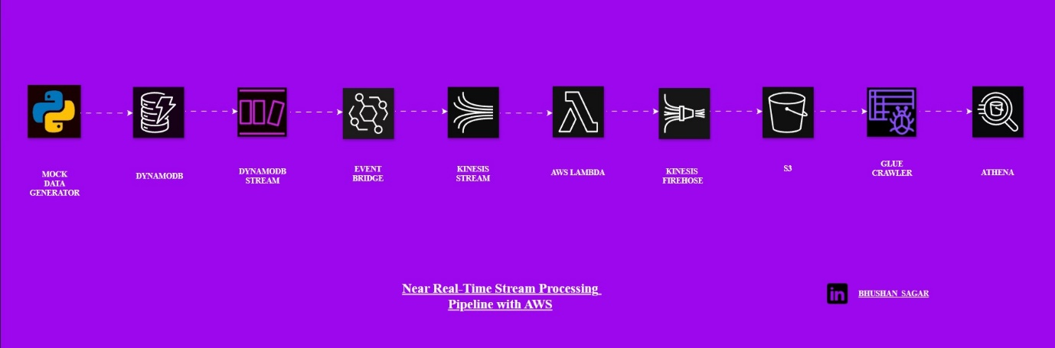

**Key Takeaway:**

Building a near real-time data processing pipeline on AWS empowers businesses to unlock the full potential of their streaming data. By leveraging scalable infrastructure and advanced analytics tools, organizations can stay ahead in today's dynamic market landscape, driving innovation and growth.

**………………………………………………………………………………………………………………………**